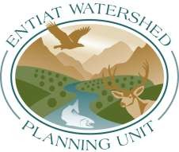

AGENDA

Feb 7th, 2017
9:00 AM – 11:45 AM
ENTIAT WATERSHED PLANNING UNIT MEETING
Entiat Grange Hall, Entiat, WA

I = Information D = Decision

9:00 PM Welcome and introductions
- Housekeeping  - Approve October 2017 EWPU meeting minutes  - Call for new business items  - Review and accept agenda | Sims
9:10 Entiat Landowner Steering Committee Update
- 2018 Goals and Planning  - WRIA 46 Plan Update and Document Review (D)  - Water Advisory Group Discussion (I) | Sims
11:00 Habitat
- Entiat Watershed Project Development Updates (I)  - UCSRB Update (I) | Sims, et al  UCSRB
11:30 Roundtable Updates | All

11:45 Meeting Close-out, Evaluation, and Adjourn

Sustainable watershed health in balance with community values, growth and vitality

