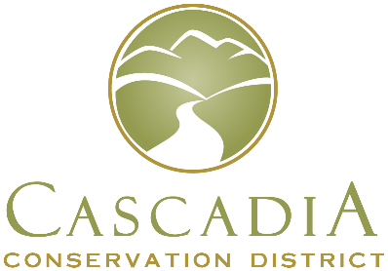
Cascadia Conservation District
1350 McKittrick St Ste B
Wenatchee, WA 98801
509-436-1601

Board of Supervisors Election Ballot Request
I, __________________________________, a registered voter of Chelan County, WA
(printed first name, middle initial, last name as it appears on your voter registration card)
living at ______________________________________________________________
Number, Street, City
request □ in person, □ in writing, □ by telephone, or □ electronically,
by □ the voter, □ a family member, or □ a registered domestic partner,
that a ballot for the Conservation District Board of Supervisors election be mailed to me at the following address:
_________________________________________________________________________
Mailing address (If the same as above, please write same.)

________________________________________
Signature [check here if the request was □ by telephone or □ electronically]
Day Time Phone Number: ___________________________
Email (optional) _____________________________________________________
Ballot requests made in person, by phone or by email to valerieh@cascadiacd.org must be received by the Cascadia Conservation District no later than 4:00 pm on February 21, 2025 to be fulfilled.
Completed ballots may be mailed or dropped off, but must be received at the District office, 1350 McKittrick St Ste B, Wenatchee, WA 98801 by noon, March 25, 2025 or dropped off at the Poll Site at Pybus Public Market, 7 N Worthen St, Wenatchee, WA between 2:00 pm and 8:00 pm on March 25, 2025. If you have any questions, call our office at 509-436-1601.

