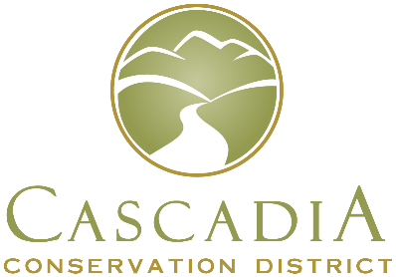
Cascadia Conservation District
14 N Mission St
Wenatchee, WA 98801
509-436-1601

Board of Supervisors Election Ballot Request
I, __________________________________, a registered voter of Chelan County, WA
(printed first name, middle initial, last name as it appears on your voter registration card)
living at ______________________________________________________________
Number, Street, City
request □ in person, □ in writing, □ by telephone, or □ electronically,
by □ the voter, □ a family member, or □ a registered domestic partner,
that a ballot for the Conservation District Board of Supervisors election be mailed to me at the following address:
_________________________________________________________________________
Mailing address (If the same as above, please write same.)

________________________________________
Signature [check here if the request was □ by telephone or □ electronically]
Day Time Phone Number: ___________________________
Email (optional) _____________________________________________________
Ballot requests made in person, by phone or by email must be received by the Cascadia Conservation District no later than 5:00 pm on February 18, 2022 to be fulfilled.
Completed ballots may be mailed or dropped off, but must be received at the District office, 14 N Mission St, Wenatchee, WA 98801 by 11:00 am, March 23, 2022 or dropped off at the Poll Site at Pybus Public Market, 7 N Worthen St, Wenatchee, WA between 12:00 pm and 6:00 pm on March 23, 2022. If you have any questions, call our office at 509-436-1601.

