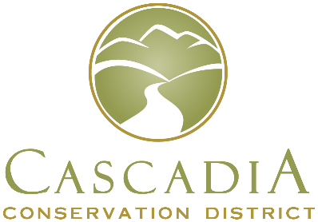
Cascadia Conservation District
1350 McKittrick St, Ste B
Wenatchee, WA 98801
509-436-1601

Board of Supervisors Election Ballot Request
I, __________________________________, a registered voter of Chelan County, WA
(printed first name, middle initial, last name as it appears on your voter registration card)
living at ______________________________________________________________
Number, Street, City
request □ in person, □ in writing, □ by telephone, or □ electronically,
by □ the voter, □ a family member, or □ a registered domestic partner,
that a ballot for the Conservation District Board of Supervisors election be mailed to me at the following address:
_________________________________________________________________________
Mailing address (If the same as above, please write same.)

________________________________________
Signature [check here if the request was □ by telephone or □ electronically]
Day Time Phone Number: ___________________________
Email (optional) _____________________________________________________
Ballot requests made in person, by phone or by email must be received by the Cascadia Conservation District no later than 4:00 pm on February 9, 2024 to be fulfilled.
Completed ballots may be mailed or dropped off, but must be received at the District office, 1350 McKittrick St, Ste B, Wenatchee, WA 98801 by 7:00 pm, March 13, 2024. If you have any questions, call our office at 509-436-1601.

