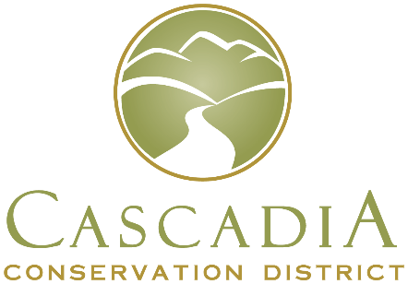
14 N Mission St. Wenatchee, WA 98801 Phone (509) 436-1601 www.cascadiacd.org

Program Contact
Joe Hill
Forest and Community Resilience Specialist
Cascadia Conservation District
(509) 436-1601

Cascadia Conservation District now accepting Fuel Break and Forest Resilience RCPP applications.
WENATCHEE, Wash. – Landowners interested in improving forest health, wildfire, and drought resilience, along with helping protect critical infrastructure, are encouraged to apply for the Regional Conservation Partnership Program (RCPP), between Oct. 1 and Oct. 31, 2022.
Cascadia Conservation District is working with the U.S. Department of Agriculture’s Natural Resources Conservation Service and other partners, to run the program, which has $2.1 million available in financial assistance. This is the first sign-up for this five-year program.
The RCPP is a voluntary program that provides financial and technical assistance to plan and implement conservation practices to address natural resource concerns. This special RCPP covers the Upper Wenatchee Valley but focusses on land near Chelan Public Utility District (PUD) infrastructure.
Funding is limited and applications will be subject to a ranking system. In order to be eligible, it is important that interested parties contact their local service center as soon as possible to ensure that their farm records are established and their eligibility paperwork is completed prior to submitting and applying for participation in NRCS programs.
For additional information, and to apply, please contact your local NRCS service center or Program Contact: Joe Hill at (509) 436-1601.

USDA is an equal opportunity provider, employer, and lender.

