**CASCADIA CONSERVATION DISTRICT**

**REGULAR DISTRICT MEETING**

**Zoom Meeting ID: 987 6961 1557**

**1350 McKittrick St.**

**Wenatchee, WA 98801**

**Friday October 18, 2024**

**1:30 p.m.**

MEMBERS PRESENT: Junell Wentz, Chair (In-Person); Dillon Miller, Vice-Chair (Zoom); Amy Bridges, Auditor (Zoom); and Kurt Hosman, Member (In-Person).

MEMBERS ABSENT: Pete Teigen, Member.

OTHERS PRESENT: The following District Staff: Ryan Williams (In-Person), Valerie Hampton (In-Person), Elizabeth Jackson (In-Person), Kelly Luebbering (In-Person), Marcy Bartelheimer (In-Person), and Nada Wentz (In-Person).

Junell Wentz, Chair, called the meeting to order at 1:34 PM

PUBLIC COMMENT: None

**Consent Agenda:** Approve September 20, 2024, Regular District Meeting Minutes, approve September Treasurer’s Report and authorize paying bills.

M/S/C Amy Bridges moved to approve the Consent Agenda. Kurt Hosman seconded. Motion passed unanimously.

CORRESPONDENCE: Kim Lancaster received an award of recognition at the NC Area Meeting for the cultural resources work she has done all over Washington State.

NATURAL RESOURCES CONSERVATION SERVICE (NRCS) REPORT: Frank Curtin

Not available.

WASHINGTON STATE CONSERVATION COMMISSION (WSCC) REPORT: Mike Baden

Not available.

STAFF REPORT: Agricultural Team – Elizabeth Jackson, Marcy Bartelheimer, Kelly Luebbering

Ag Team Accomplishments 2024 Cultivating Our Impact Presentation

The team talked about the increase in the number of grants and funding available for agriculture projects. The District has received a lot of interest in community gardens, nutrient management on farmland, and irrigation plans for gardens, orchards and vineyards. The team’s goal is to reconnect folks with best practices for land use in ag areas as well as stream side areas. Garden educational workshops is an area of interest in the community. Soil health is another area of growing interest.

The team has been working on educational workshops for pollinator habitat, cost share projects for vineyards and partnerships with gardening groups. Salmon Safe farm certifications is also on the rise. Mailers were sent to orchardists recently highlighting the cost share opportunities available. The Board thanked the Ag Team for a very informative presentation.

GRANT APPLICATIONS, CONTRACT REVIEW AND APPROVAL

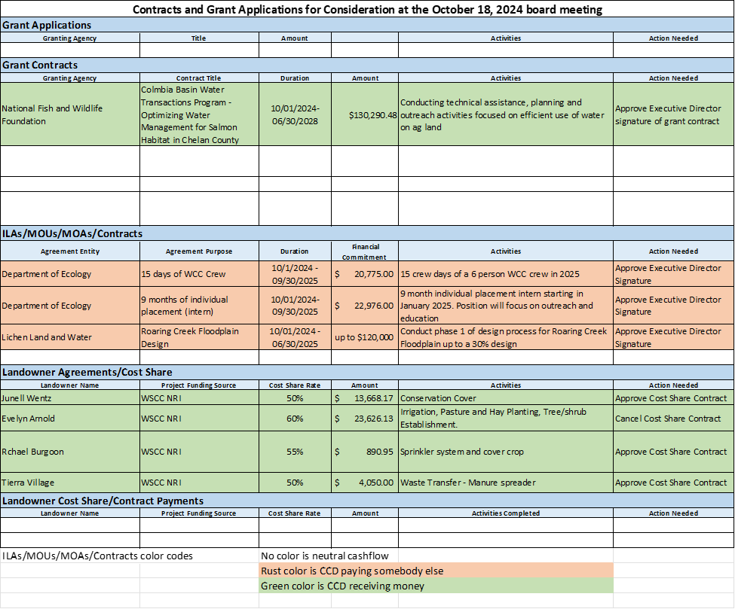

Ryan asked that the conservation cover cost share item be discussed and approved separately from the rest of the Contract list.

M/S/C Dillon Miller moved to approve the Contracts, Cost Share Agreements and Cost Share Payments as presented, excluding the Junell Wentz NRI cost share agreement. Amy Bridges seconded. Motion passed unanimously.

**The Junell Wentz Cost Share Agreement:** The agreement is for a conservation cover. Junell abstained from this portion of the Contract List approval and asked that Kurt chair this portion of the meeting. Kurt accepted.

M/S/C Amy Bridges moved to approve the Junell Wentz NRI cost share agreement. Dillon

Miller seconded. The motion passed. Junell Wentz abstained.

Kurt handed the meeting back to Junell for the remaining business.

**Other Business:**

**Health Care Coverage for 2025:** Ryan shared a spreadsheet with the group showing the options and cost. He recommended going with the same benefit levels - $500 deductible, dental 2000, vision plan and wellness program. The Board asked that staff try to participate in the wellness program offered in order to get a discount on the coverage.

M/S/C Kurt Hosman made a motion to approve the 2025 Health Care Coverage recommendation. Amy Bridges seconded. Motion passed unanimously.

**Letter to South Douglas Conservation District Board of Supervisors:** Ryan asked the Board Members to give their input on drafting a letter requesting continued support of the youth education programs including help with staff costs for instruction. If the Board is in support of a letter, he offered to draft it and bring it to the next meeting for approval. The Board directed him to proceed.

**Executive Director’s Report:**

**Annual Meeting in Spokane:** Ryan asked the Board to let him know by the first of November if they would like to attend the meeting in Spokane December 2 – 4. He would like to secure rooms for those attending. The resolutions discussed at the Area Meeting will be put to a vote at the Annual Meeting. Only Supervisors are allowed to vote. The business meeting and voting will take place on the 3rd.

**Finance and Operation Director Update:** There were not many applicants for the position. None were qualified. A degree in accounting, or lots of experience in accounting is very important for this position. Ryan will update the advertisement to continue through November 1, as well as find additional places to advertise. He is considering edits to the pay scale as well.

**Strategic Planning Meeting:** The planning meeting is set for December 9 at the Forest Service building. It will be an all-day meeting. Ryan will send out additional information for the Board to review next week.

**November Meeting Date, Location and Time:** The next regular meeting is November 15th, 2024, at 1:30 pm. at the Cascadia CD office, 1350 McKittrick St. Ste. B, Wenatchee, WA 98801.

The meeting adjourned at 3:27 PM.

**Summary of Official Actions:**

Approved the Consent Agenda;

Approved the following contracts, agreements and cost share payments:

**Grant Contracts:**

National Fish and Wildlife Foundation – Columbia Basin Water Transactions Program to

conduct technical assistance, planning and outreach activities focused on efficient use of water on ag land;

**ILAs / MOUs / MOAs / Contracts:**

Dept. of Ecology – 15 crew days for 6 WCC crew members work in 2025;

Dept. of Ecology – 9 months for individual placement intern beginning in January 2025;

Lichen Land and Water – Roaring Creek Floodplain design, phase 1;

**Landowner Agreements/Cost Share:**

Evelyn Arnold – WSCC NRI cost share for irrigation, pasture and hay planting, tree/shrub

establishment;

Rachel Burgoon – WSCC NRI cost share for sprinkler system and cover crop;

Tierra Village – WSCC NRI cost share for waste transfer – manure spreader;

**Landowner Cost Share:**

Junell Wentz – WSCC NRI cost share for conservation cover;

Approved the 2025 Health Care Coverage recommendation.

CHAIR_______________________________________________________________________

OFFICE ASSISTANT____________________________________________________